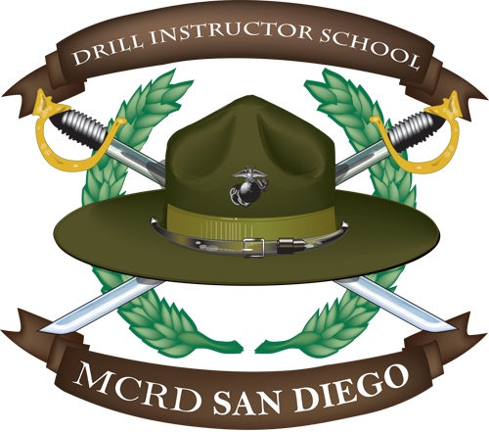

Suggested Class Materials List:
1 roll clear packing tape
1 glow strap*
3 rolls recruit white tape
1 Marking kit (1 inch)
1 1”x12” inch ruler
1 package of 3x5 index cards
1 package of 5x8 index cards
1 pr. scissors
1 8”x11” Binder (1 inch no film) *
1 5”x8” Binder (1 inch no film) *
2 combination locks*

* Refer to pictures below
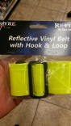 glow strap
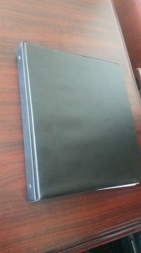 8x11 binder
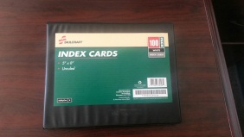 5x8 binder
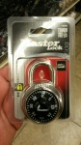 lock

