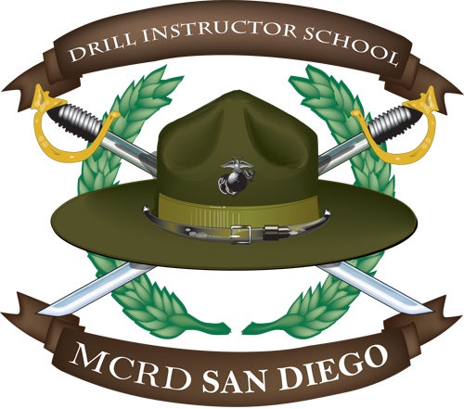

DRILL INSTRUCTOR SCHOOL
- Week 1: Processing (Intial Pft, Ht/Wt, Compliance/Non-Compliance Screening, Finances, Family Stability, Introduction Classes Instructor Packages)
- Week 2: 6 Classes For 0911 Development, 1 Uniform Inspection, 2 Pt Events, 6 Cod Sessions, And Various Briefs From Outside Agencies
- Week 3: 6 Classes For 0911 Development, 1 Pt Event, Initial Swim Qualification, 5-Mile Conditioning Hike, 1 Uniform Inspection, 6 Cod Sessions, Guidon Verification Test, And Various Briefs From Outside Agencies
- Week 4: 8 Classes For 0911 Development, 3 Pt Events, 8 Cod Sessions, 1 Written And Performance Examination, 1 Uniform Inspection, And Various Briefs From Outside Agencies
- Week 5: 8 Classes For 0911 Development, 1 Pt Event, Initial Cft, 8-Mile Conditioning Hike, 6 Cod Sessions, 1 Written Examination, 1 Uniform Inspection, And Various Briefs From Outside Agencies
- Week 6: 4 Classes For 0911 Development, Intermediate Pft, Final Swim Qualification, 6 Cod Sessions, 1 Performance Examination, And Various Briefs From Outside Agencies
- Week 7: 5 Classes For 0911 Development, 2 Pt Events, 1 Uniform Inspection, 7 Cod Sessions, And Various Briefs From Outside Agencies
- Week 8: 1 Class For 0911 Development, 2 Pt Events, 1 Written And Performance Examination, And Various Briefs From Outside Agencies
- Week 9: Bwt Week (Field Skills Training, Rto Of Crucible, Viewing Of Emblem Ceremony, 1 Practical Application Examination, And 1 Written Examination)
- Week 10: Finals Week (Cod Written And Peformance Examinations, Final Pft, Final Cft, Final Sop Examination, Directors Inspection, And Class Photos)
- Week 11: Rto Week (Students Observe Recruit Training And Participate In Routine Events Under The Direct Supervision Of Signed Off Drill Instructors)
- Week 12: Graduation

