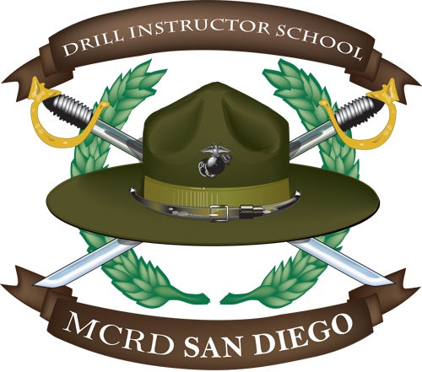

Regularity of exercise is far more important than the amount performed on a given day. A Marine with orders to Drill Instructor School should PT a minimum of 3 days a week. Drill Instructor School students should arrive with a high level of cardiovascular endurance and upper body strength. However, any good physical training program takes injury prevention into account. For example, long distance runs are excellent for developing cardiovascular endurance. However, sudden increases in workload (especially when it comes to running) can easily lead to lower extremity injuries such as stress fractures.

Nutrition is a critical aspect of fitness training that some individuals overlook. Prospective DI students who need advice on programming nutrition into their PT plan should seek out their unit Physical Training representative or complete the MarineNet course on nutrition (SFNUTRIT00).

In October 2012, the Marine Corps announced the High Intensity Tactical Training Program (HITT). There are 5 components of this functional fitness program:

1. Injury Prevention
2. Strength and Power
3. Speed, Agility and Endurance
4. Flexibility and Core Stability
5. Nutrition

Each of these five principles should be observed when designing any physical training program.

A sample fitness program follows. Prospective DI students are advised that this is a generic example. Marines need to take into account local factors such as availability of training equipment and personal fitness level.

Day 1
Cardiovascular: 3 mile run
Strength: Daily 16 (10 reps), 1 set of maximum pull-ups & crunches.
Day 2
Cardiovascular:
Sprints – 1 mile warm up Sprint 400m X 3, Sprint 200m X 3, and Sprint 100m X 3
Progression with the sprints 1st 50%, 2nd 75% and 3rd 100%.
Day 3
**OFF-DAY**
Day 4
Obstacle course X 2.
Day 5
Cardiovascular: 3 mile Fartlek
Strength: Daily 16 (10 reps), 2 sets maximum crunches & pull-ups

WEEK 1
DAY 1: Warm up/Stretch, Daily 16 (10 reps), 3 mile easy run.
DAY 2: Warm up/Stretch, Pool for laps (500 meters) and WSB at a minimum.
DAY 3 Sprint interval - ½ mile warm up Sprint 200m X 3, Sprint 100m X 3, and Sprint 50m X 3 Crunches X 1 minute, Pyramid pulls 2,3,4,5,6, 5,4,3,2
WEEK 2
DAY 1: Warm up/Stretch, 3 mile easy run, Daily 16 (10 reps)
DAY 2: 2 mile run
DAY 3: Warm up/Stretch, Pool for laps (500m) and WSB at minimum.
WEEK 3
DAY 1: Warm up/Stretch, 1.0 mile easy run (boots), Obstacle course X2
DAY 2: Sprints interval ½ mile warm up Sprint 200m X 2, Sprint 100m X 2, and Sprint 50m X 2
DAY 3: PFT
WEEK 4
DAY 1: Warm up/Stretch, Interval Run: 3 miles, Daily 16 (10 reps)
DAY 2: Warm up/Stretch, 2 mile easy run, Daily 16 (10 Reps), 2 sets maximum crunches & pull-ups.
DAY 3: Warm-up/Daily 16 (12 Reps) 2 mile Last Man Up run
WEEK 5
DAY 1: Warm up/Stretch, 3 mile Fartlek to include Daily 16 (10 reps)
DAY 2: Pyramid pull-ups 2-3-4-5-5-4-3-2
DAY 3: Warm up/Stretch, Pool for laps (500m) and WSB at minimum.
WEEK 6
DAY 1: 2 mile run change over to boots and uts Obstacle course X2
DAY 2: Warm up/Stretch, 3 mile Interval run, Daily 16 (10 reps)
DAY 3: Daily 16 1.5 mile run change over to boots and uts climb rope X 2
WEEK 7
DAY 1: Crunches X 3-1st Set 1min 30sec, 2nd Set 1min, 3rd Set 30 sec. Pulls X 3…to reach your age. If you are 33 years old your first set should be 14, the next set you do 7, then you need to rep out 9 to be able to get a total adding to your age.
DAY 2: Warm up/Stretch, Pool for laps (500m) and WSB at a minimum.
DAY 3: 2 mile run
WEEK 8
DAY 1: Warm up/Stretch, 3 mile Interval run, Daily 16 (10 reps)
DAY 2: 2 mile run, No Crunches and No Pulls ups
DAY 3: PFT
As you progress in your conditioning, gradually increase the mileage to 4 miles in PT gear. In addition, students should prepare themselves for our conditioning hikes by beginning with a 5 mile, 782 gear-only force march (3 mph pace) and gradually work themselves up to 10 miles with a 45-pound pack and weapon.
If a Marine is a weak swimmer he/she should work primarily on qualifying as WSB, which is the current minimum at Drill Instructor School. In addition, lap swimming will not only help the student feel more confident in the water, but is an excellent means of physical conditioning which does not cause undue stress on the joints or bones.
Daily 16 Stretch and Exercise Cards
The daily 16 is a comprehensive warm-up, cool down and conditioning exercise. It targets the importance of a proper warm-up and cool down which includes light activity, mobility exercises, and flexibility training.
DYNAMIC WARM-UP BEFORE PT
VA x 10
Bicycle, Slow x 10
Hip & Back x 10 sec
Flip Flop x 10
Bicycle, Moderate x 10
Cobra x 10 sec
Prone Row x 10
Push up x 10
Upper Back Stretch x 10 sec
Trunk Twist x 10
Squat Touch x 10 each leg
Quad stretch x 10 sec
Run in Place, Chest Out x 15 sec
Reverse Lunge and Reach x 10
Optional Hamstring x 10 sec
Arm Running in place x 15 sec
Laying ITB Stretch x 10 sec
CONDITIONING EXERCISES
Side straddle hop
Crunches
Push ups
Elbow-knee cruches
Diamond push ups
Front lunges
Side straddle hop
(Repetitions are 4-count.)

